- Šta je to gradski saobraćaj?
____________________________________________________________________________________________________________________________________________________________
- Razvoj gradova uslovljen razvojem saobraćaja prolazi kroz tri faze, objasniti ih.
____________________________________________________________________________________________________________________________________________________________________________________________________________________________________________________________________________________________________________________________________________________________________________________________________________________________________________________________________________________________________________________________________________________________________________________________________________________________________________________________________________________________________________________________________________________________________________________________________________________________________________________________________________________________________________________________________________________________________________________________________________________________________________________________________________________________________________________________________
- Sistem gradskog prevoza je organizovan u tri međusobno povezana oblika:_______________________________________________________________________________________________________________________________________________________
- Šta su to pješačke zone?
____________________________________________________________________________________________________________________________________________________________
- Šta su to gradski putevi?
____________________________________________________________________________________________________________________________________________________________
- Šta su to transportni terminali?
____________________________________________________________________________________________________________________________________________________________
- Prema vrsti komunikacije i prevoznog sredstva u okviru vodenog saobraćaja razlikuje se:__________________________________________________________________________________________________________________________________________________________
- Počeci organizovanog pomorskog saobraćaja vezani su za koje more i koji narod?
____________________________________________________________________________________________________________________________________________________________
- Prije velikih geografskih otkrića, koje more je bilo centar svjetskog pomorstva i trgovine?
____________________________________________________________________________________________________________________________________________________________
- Koja istorijska dešavanja su bila inicijatori velikih geografskih otkrića?
____________________________________________________________________________________________________________________________________________________________
- Prenošenjem težišta svjetskog mora na Atlantski okean, razvijaju se nove pomorske sile-države:
____________________________________________________________________________________________________________________________________________________________
- Koji prirodni faktori utiču na izgradnju luka?
__________________________________________________________________________________________________________________________________________________________________________________________________________________________________________
- Sem prirodnih faktora, koji faktori utiču na izgradnju luka?
______________________________________________________________________________________________________________________________________________________________________________________________________________________________________________________________________________________________________________________________________________________________________________________________________
- Koja su tri kriterijuma za klasifikaciju luka, objasniti svaki posebno?
________________________________________________________________________________________________________________________________________________________________________________________________________________________________________________________________________________________________________________________________________________________________________________________________________________________________________________________________________________________________________________________________________________________________________________________________________________________________________________
- Na nijemoj karti svijeta, brojevima ( od 1-10) označiti svjetsku pomorsku flotu država:
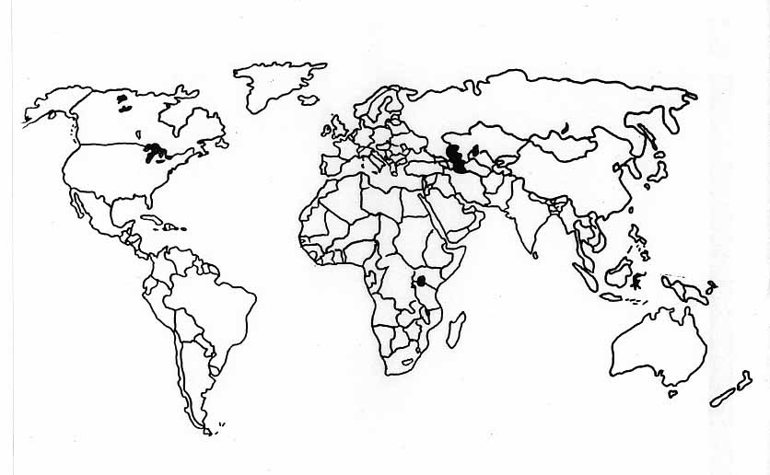

- Na nijemoj karti svijeta brojevima (1-10) označiti brodogradnju u vodećim državama:
- U strukturi pomorskog robnog prometa najveće učešće imaju:_______________________________________________________________________________________________________________________________________________________

- Objasniti kako tankerski transport ugrožava svjetsko more?

________________________________________________________________________________________________________________________________________________________________________________________________________________________________________________________________________________________________________________________
- Koje države su glavni proizvođači gvozdene rude, a gdje su skoncentrisani metalurški centri?
__________________________________________________________________________________________________________________________________________________________________________________________________________________________________________
- Kuda vode glavni tokovi trasnporta uglja?
________________________________________________________________________________________________________________________________________________________________________________________________________________________________________________________________________________________________________________________

- Objasniti značaj trajektne plovidbe.
__________________________________________________________________________________________________________________________________________________________________________________________________________________________________________
- Na nijemoj karti svijeta označiti glavne svjetske pomorske pravce?
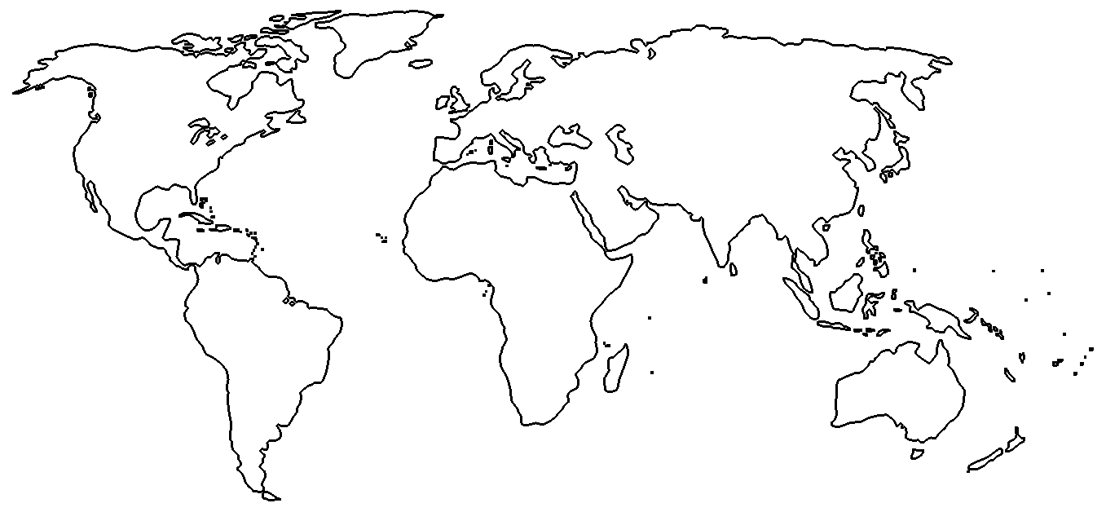
- Kada je izgrađen Suecki kanal i koji je njegov značaj?

__________________________________________________________________________________________________________________________________________________________________________________________________________________________________________
- Kada je izgrađen Panamski kanal i koji je njegov značaj?
__________________________________________________________________________________________________________________________________________________________________________________________________________________________________________
- Koji je značaj Korintskog kanala?
____________________________________________________________________________________________________________________________________________________________
- Koji je značaj Kilskog kanala?
____________________________________________________________________________________________________________________________________________________________

- Koja je prednost „saobraćaja na unutrašnjim vodama“ u odnosu na kopnene vrste saobraćaja?
____________________________________________________________________________________________________________________________________________________________
- Koji su nedostaci saobraćaja na „unutrašnjim vodama“?
__________________________________________________________________________________________________________________________________________________________________________________________________________________________________________
- Koji su najznačajniji i najveći plovni sistemi na unutrašnjim vodama?
__________________________________________________________________________________________________________________________________________________________________________________________________________________________________________________________________________________________________________________________________________________________________________________________________________________________________________________________________________________________________________________________________________________________________________________________________________________________________________________________________________________________________________________________________________________________________________________________________________________________________________________________________________________________

